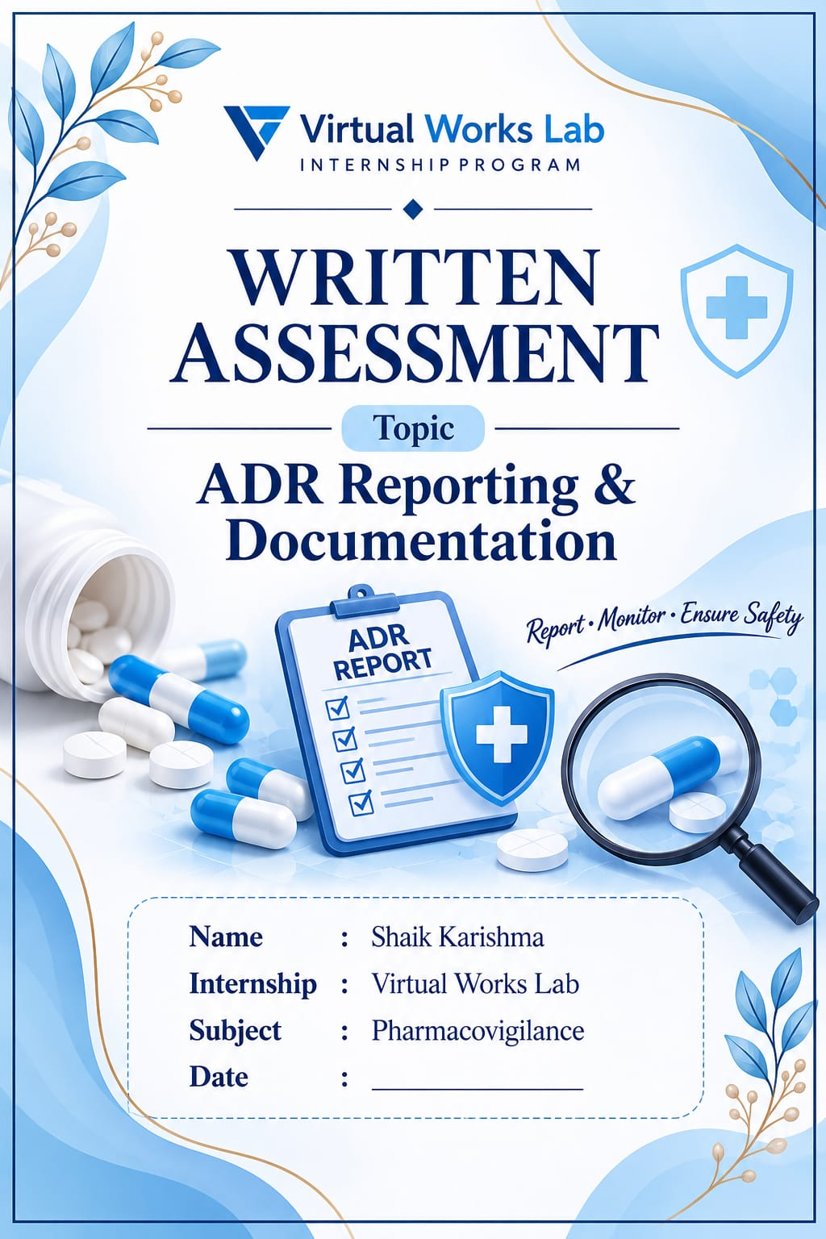
AN ADVERSE DRUG REACTION (ADR)
An Adverse Drug Reaction (ADR) is a harmful, unintended and noxious response to a medicine when it is used at normal doses for prevention, diagnosis or treatment of a disease.
How to fill an Adverse Drug Reaction (ADR) Reporting Form
An ADR reporting form is used to report any unwanted or harmful reaction experienced by a patient after taking a medicine.
In India, ADRs can be reported under the Pharmacovigilance Programme of India (PvPI).
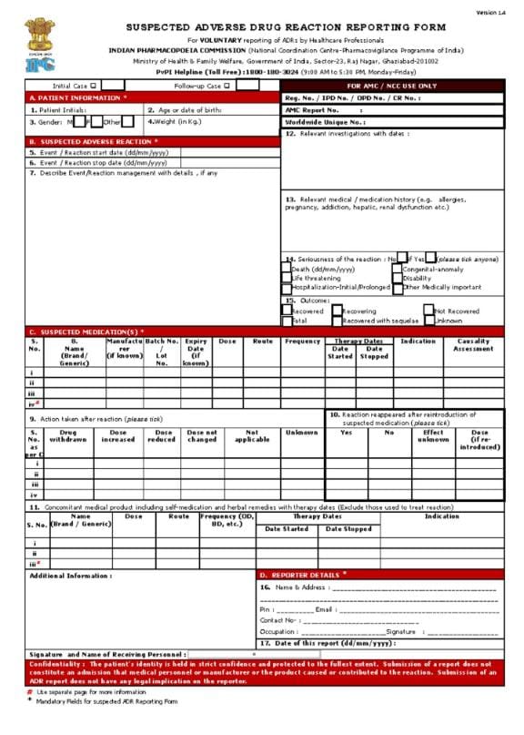

A.PATIENT INFORMATION IN ADR REPORTING FORM
Patient information refers to the basic personal details of the patient who experienced a suspected Adverse Drug Reaction (ADR).Details required in the ADR form
- Patient initials: First letters of the patient's name.
- Age: Age of the patient in years or months.
- Gender: Male or Female.
- Weight: Body weight in kilograms (kg).
- Height: Height in centimetres (cm), if required.
- Patient identification number: Hospital or medical record number, if available.
B. SUSPECTED ADVERSE REACTION DETAILS
Write the reaction experienced by the patient.
- Description of reaction
- Date of onset
- Date of recovery
- Whether the reaction is serious or non-serious
- Outcome of the reaction
Example: Patient developed skin rash and itching after taking a medicine.
C. SUSPECTED MEDICINE DETAILS
Mention the medicine suspected of causing the reaction.
- Name of the drug
- Dose
- Route of administration
- Frequency
- Start date
- Stop date
- Indication (reason for taking medicine)
Example:
Drug: Amoxicillin
Dose: 500 mg
Route: Oral
Frequency: Twice daily
Indication: Bacterial infection
Reaction Abated After Drug Stopped Or Dose Reduced
Reaction abated after drug stopped or dose reduced means the adverse drug reaction (ADR) decreases or disappears after stopping the suspected medicine or reducing its dose.This is called Dechallenge.
There are two possible answers in the ADR reporting form:
- Yes: The reaction improved or disappeared after stopping the drug or reducing its dose.
- No: The reaction did not improve after stopping the drug or reducing its dose.
- Unknown: It is not known whether the reaction improved.
Example:
A patient develops a skin rash after taking amoxicillin. After stopping the medicine, the rash gradually disappears. Answer in ADR form: YES.

Remember: Dechallenge helps assess whether a drug may be responsible for an adverse reaction. It does not prove causality by itself.

Reaction Reappeared After Reintroduction
Reaction reappeared after reintroduction means the same adverse drug reaction occurs again when the suspected medicine is given to the patient after it was previously stopped.This is called Rechallenge.
Options in the ADR reporting form
- Yes: The same reaction occurred again after restarting the medicine.
- No: The reaction did not occur again after restarting the medicine.
- Unknown: It is not known whether the reaction occurred again.
- Not applicable: The medicine was not reintroduced.
Example
A patient develops a skin rash after taking amoxicillin. The medicine is stopped, and the rash disappears. Later, the same medicine is restarted, and the rash appears again.
Concomitant Medical Products & Therapy Dates (Including Self-Medication & Herbal Remedies)
Concomitant medical products are all other medicines or healthcare products taken by a patient along with the suspected drug during the same period. It includes prescription medicines, self-medication, OTC medicines and herbal remedies.
- Name of the medicine.
- Dose of the medicine.
- Route of administration.
- Frequency of use.
- Start date.
- Stop date.
- Reason for taking the medicine.
Relevant Tests / Laboratory Data
Relevant tests or laboratory data refer to medical tests and investigations performed on a patient to identify, confirm or monitor an adverse drug reaction (ADR).
What should be mentioned in the form?
- Name of the test.
- Date of investigation.
- Laboratory results.
- Relevant abnormal findings.
- If tests are not Name performed: Write "Not done" or "Not available".
Relevant Medical / Medication History
Relevant medical or medication history refers to the patient's previous and existing health conditions, allergies and medicines taken before the suspected adverse drug reaction (ADR).
What information should be mentioned?
- Previous medical conditions.
- History of drug allergies.
- Previous adverse drug reactions.
- History of liver or kidney disease.
- Pregnancy or breastfeeding status, if relevant.
- Previous medicines taken by the patient.
- Any ongoing medical treatment.
Seriousness Of Reaction
Seriousness of an adverse drug reaction (ADR) refers to whether the reaction causes major harm to the patient or leads to important medical consequences.
Criteria for serious ADR
- Death: The reaction results in the patient's death.
- Life-threatening: The reaction puts the patient's life at immediate risk.
- Hospitalization: The patient requires hospital admission.
- Prolonged hospitalization: The reaction increases the duration of hospital stay.
- Disability: Causes significant or permanent disability.
- Congenital anomaly: Causes birth defects in a baby.
- Other medically important conditions: Requires medical intervention to prevent serious outcomes.
Types Of ADR Outcomes
- Recovered: The patient has completely recovered from the reaction.
- Recovering: The patient's condition is improving but recovery is not yet complete.
- Not recovered: The reaction is still present.
- Recovered with sequelae: The patient has recovered but has permanent or lasting effects.
- Fatal: The reaction resulted in the patient's death.
- Unknown: The outcome is not known.
D.REPORTER
- Profession: Pharmacist, doctor, nurse or other healthcare professional.
- Address: Hospital, clinic or institution address.
- Contact number: Mobile or telephone number.
- Email ID: Official or personal email address.
- Date of reporting: Date on which the ADR is reported.
- Signature: Signature of the reporter, if required.
CASE EXERCISE IN PHARMACOVIGILANCE (ADR)
A case exercise is a practical activity in which a suspected adverse drug reaction is studied to understand how to identify, assess, document and report the reaction using an ADR reporting form.
Case Study 1: Amoxicillin-induced skin rash
Patient information:
Patient initials: A.B.
Age: 25 years
Gender: Female
Weight: 55 kg
Suspected drug details:
Drug name: Amoxicillin
Dose: 500 mg
Route: Oral
Frequency: Twice daily
Indication: Bacterial infection
Adverse reaction details:
Reaction: Skin rash and itching.
Onset: After taking the medicine.
Action taken: Medicine discontinued.
Reaction abated after stopping drug: Yes.
Reaction reappeared after reintroduction: Not done.
Other details:
Concomitant medicines: None reported.
Laboratory tests: Not done.
Medical history: No relevant history reported.
Seriousness: Non-serious.
Outcome: Recovered.
ESSENTIAL INFORMATION FOR ADR REPORTING
Essential information for ADR reporting refers to the minimum details required to document and submit a suspected Adverse Drug Reaction (ADR) report.
Four essential elements of an ADR report
- Identifiable patient: Basic information about the patient who experienced the reaction.
- Identifiable reporter: Details of the person reporting the suspected ADR.
- Suspected medicine: Name of the drug suspected of causing the reaction.
- Suspected adverse reaction: Description of the harmful or unwanted reaction.
CONFIDENTIALITY
Confidentiality refers to protecting the personal and medical information of patients and ensuring that their details are not shared with unauthorized persons during Adverse Drug Reaction (ADR) reporting.
Important points of confidentiality
- Maintain patient privacy.
- Do not disclose the patient's name or personal details unnecessarily.
- Keep medical records safe and secure.
- Share ADR information only with authorized healthcare professionals and authorities.
- Use patient initials or identification codes wherever appropriate.
- Do not share patient information on social media or with unauthorized persons.



